**Database Systems**

**Fall 2017 – Final Project Submission**

* **Introduction**: Description of the project in general
* **High-level Design**: An image of the ER model in Chen notation
* **Database Design**: An image of the relational model in crow’s foot notation (include the mwb file with your code)
* **Methodology**: Description of the development tools used.
* **GUI**: Include a screenshot of every screen in your system, and for each screen, explain the SQL statement(s) that are used in this interface. For example, include the SQL code that loads the data onto the screen, and/or the SQL code that is executed when buttons are pressed, etc.
* **Development**: Description of how your team members worked together – who did what. Describe your impressions of the project in general.

**Introduction**

Our project is a website for ordering fast-food. On the website user chooses food from menu and amount of that food. At the bottom side of page will be printed chosen foods and the total cost. After that, user inputs his/her personal information for delivery and clicks send button. After clicking, data taken from user will be inserted into database and page will be refreshed.

**High-level design**

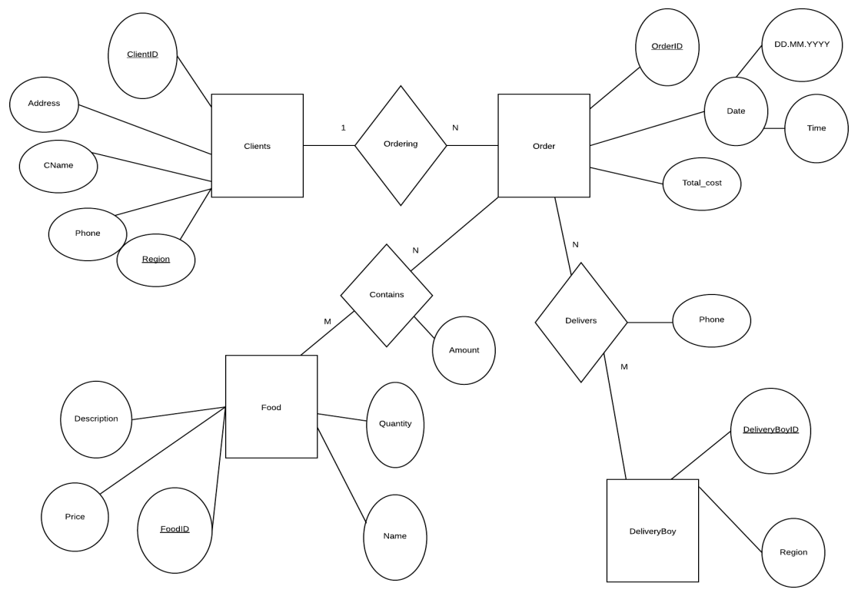

**Database design**

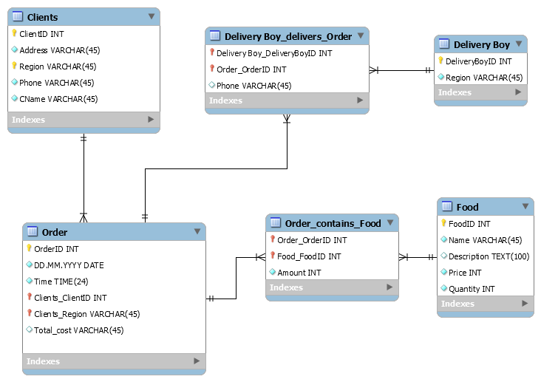

**Methodology**

First of all, we created front-end design using html and CSS language. Moreover, JavaScript was used to create animations, scrolling and make calculations. phpMyAdmin in WampServer was used to create database on localhost server and to use it. In website php language was used to create and to implement mysql queries.

**GUI**

First page

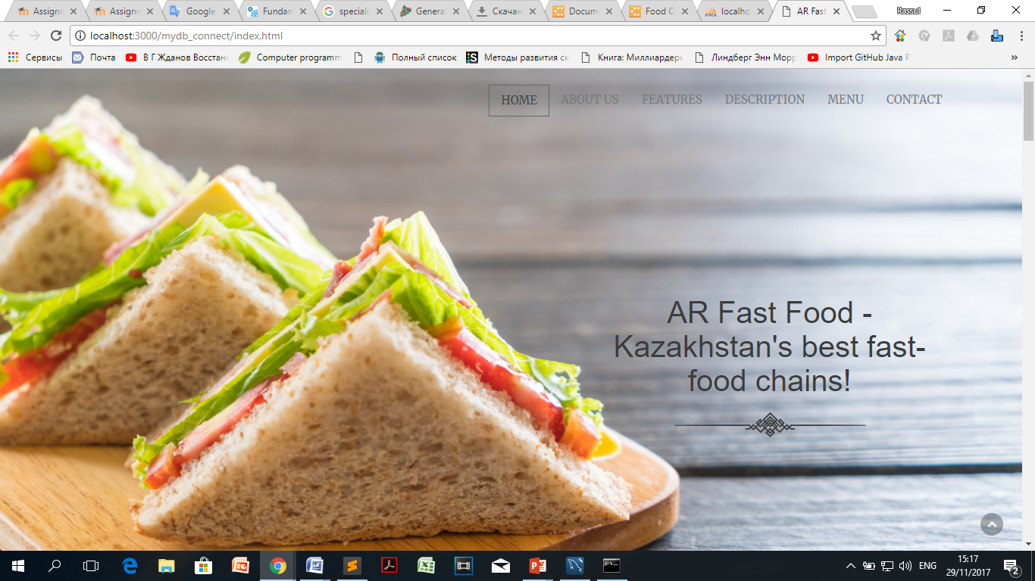

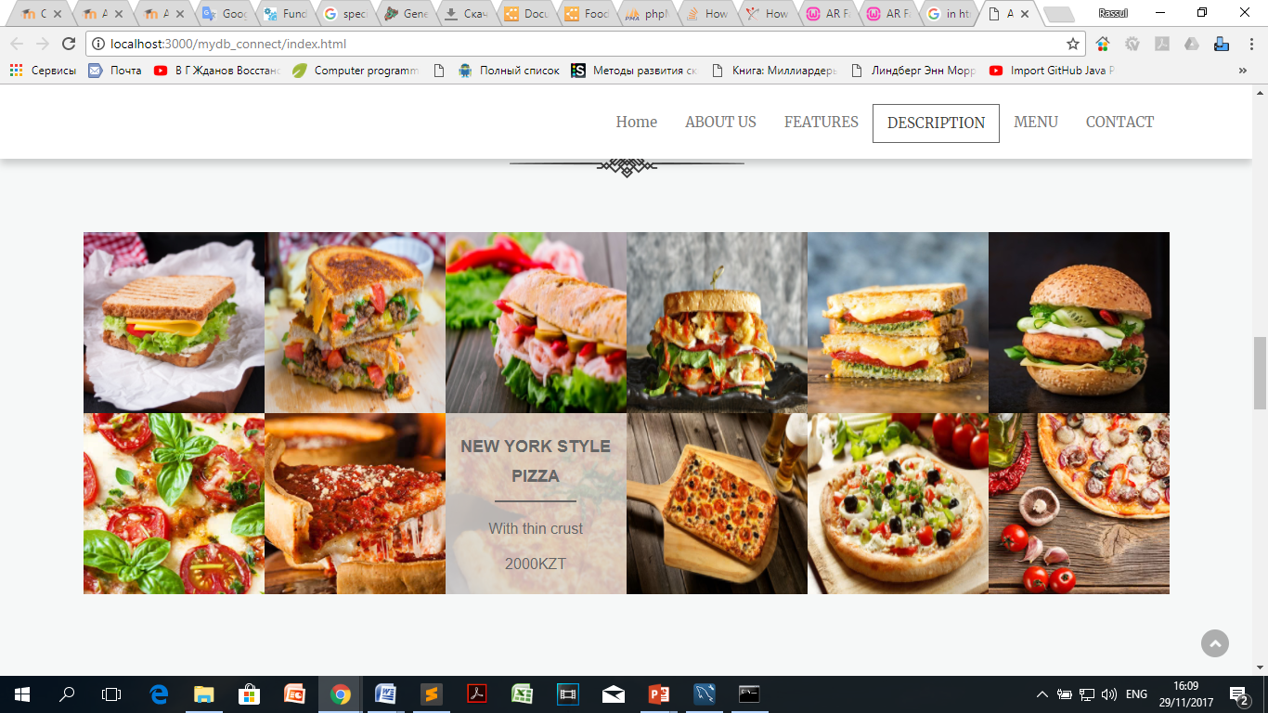

Here, mysqli_query was called in food.php file and the results transferred to index.html file via JavaScript. The query gives us name, description and the price of food.

“SELECT Name, Description, Price

FROM `food`;”

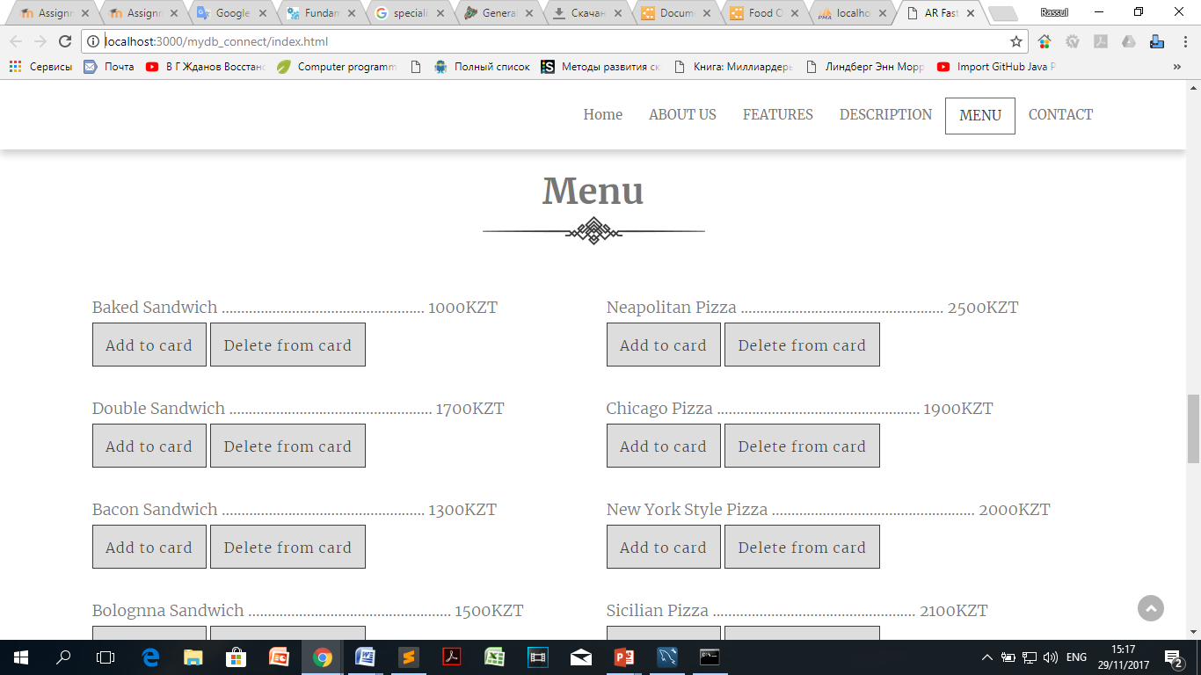

Here, user can add and delete food from card. Added foods will be showed below in card. These functions were made by JS.

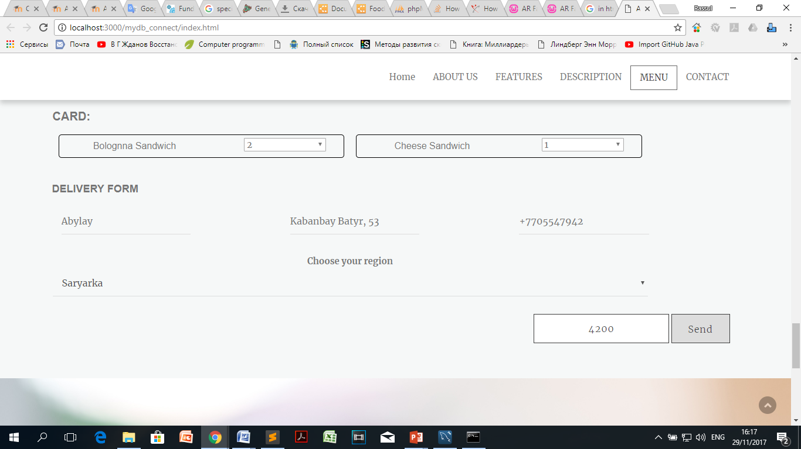

In the card, user choose amount of certain food. The total cost was computed in JS and showed below the card. User inputs his/her name, address, telephone number and chooses region. After clicking send button, all information will be added into database. After that, delivery boy who attached to that region will deliver the order.

Some examples of mysqli_queries:

"INSERT INTO `clients` (`CName`, `Address`, `phone`, `Region`) VALUES ('$name', '$address', '$phone', '$region')"

"INSERT INTO `order` (`Total_cost`, `DD.MM.YYYY`, `Time`, `Clients_ClientID`, `Clients_Region`) VALUES ('$total_cost', '$date', '$time', (SELECT max(ClientID) FROM clients), '$region')"

"INSERT INTO `order_contains_food` (`Order_OrderID`, `Food_FoodID`, `Amount`) VALUES ((SELECT max(OrderID) FROM `order`),'12', '$c12')"

**Development**

In the beginning, our team had struggled with understanding of the topics. Firstly, we made an ER Diagram and Relational model diagrams for our project. However, after going to live grading, professor pointed out to some errors in our work and only after that we were able to complete those exercises. Afterwards, we made GUI mock-up for our project which was based on android application. However, for the final version of the project, we chose to make a website. Working on website was intensive and we divided tasks equally between us. For example, when someone was writing the main code for the project, second student at the same time was searching for other data like images, descriptions. We interchangeably wrote codes for the website and there was no piece of time when someone was not doing any work. In general, we honestly enjoyed working on this project, because it helped to fully understand the usage of database systems. In our opinion, doing a project is the most helpful part of any course, because students will be able to practice the things they’ve learned on that course. Practice makes perfect and we are happy to finish our project.